HIGHTHROUGHPUT PROJECT

1. Getting the father dataset

Code used: wget <https://zenodo.org/record/3243160/files/father_R1.fq.gz>

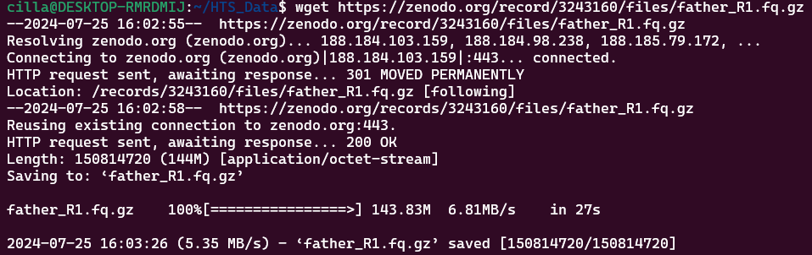

wget https://zenodo.org/record/3243160/files/father_R2.fq.gz

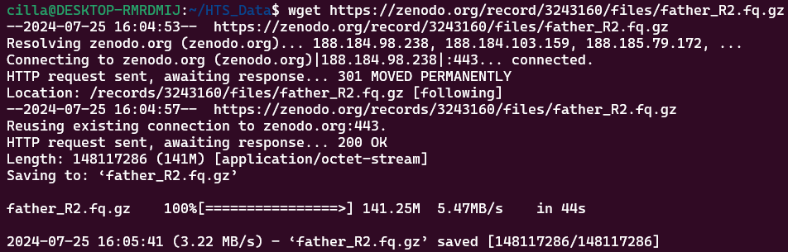

1. Getting the Mother dataset

Codes used: wget <https://zenodo.org/record/3243160/files/mother_R1.fq.gz>

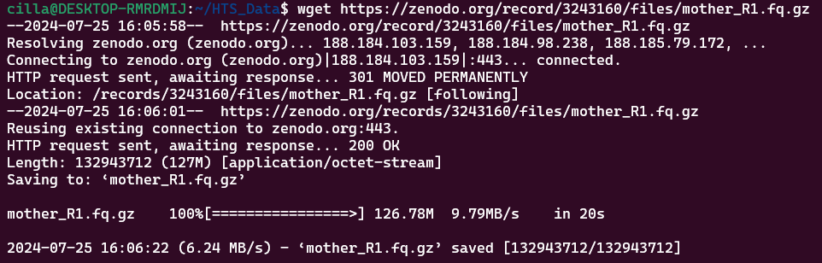

wget https://zenodo.org/record/3243160/files/mother_R2.fq.gz

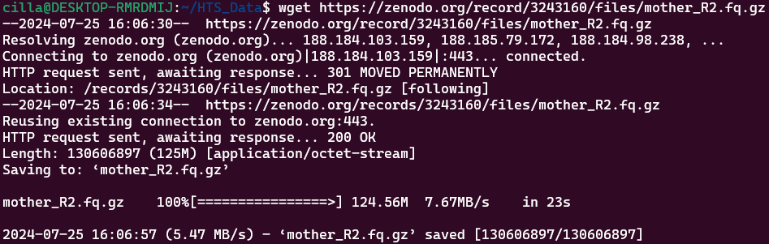

1. Child dataset

Code used: wget https://zenodo.org/record/3243160/files/proband_R1.fq.gz

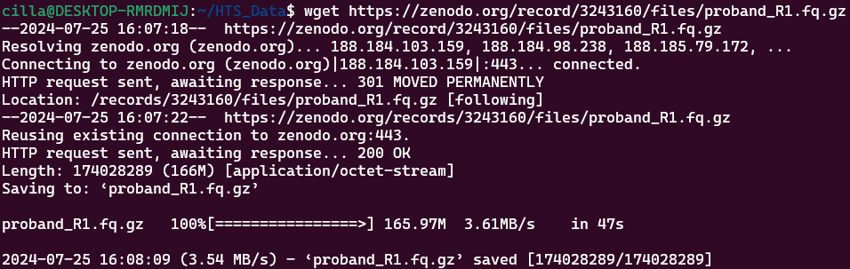

Code used: wget https://zenodo.org/record/3243160/files/proband_R2.fq.gz

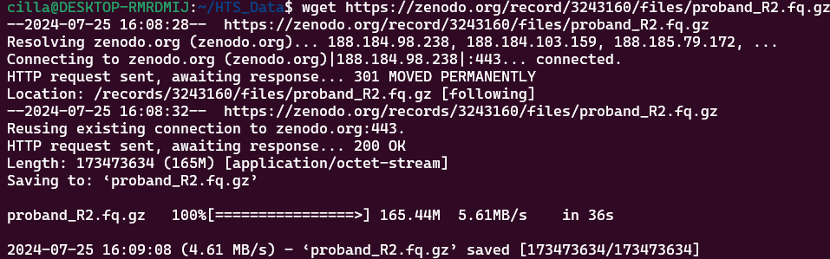

STEP2: GETTING THE hg19 version of the human dataset

Code used: wget <https://zenodo.org/record/3243160/files/hg19_chr8.fa.gz>

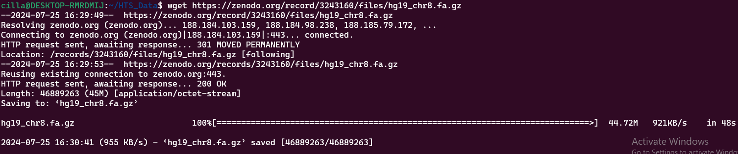

STEP 3

Running Fatsqc on the datasets

Code used: fastqc father_R1.fq.gz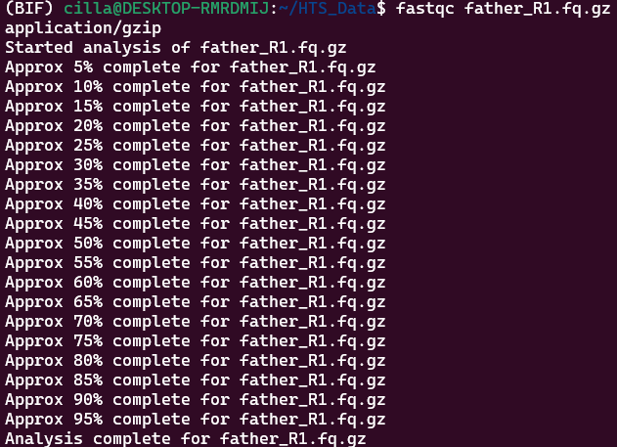

ii. fastqc father_R2.fq.gz

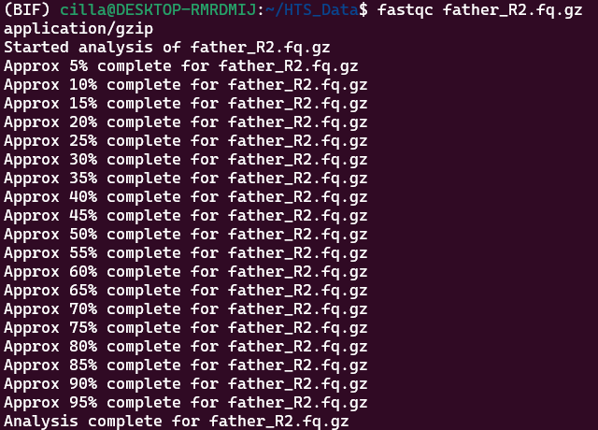

iii. fastqc mother_R1.fq.gz

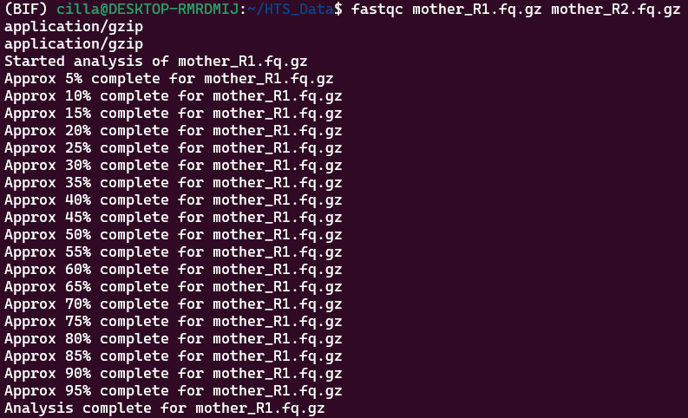

iv. fastqc mother_R2.fq.gz

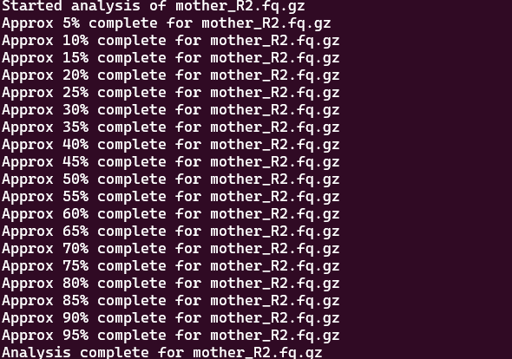

v. fastqc proband_R1.fq.gz

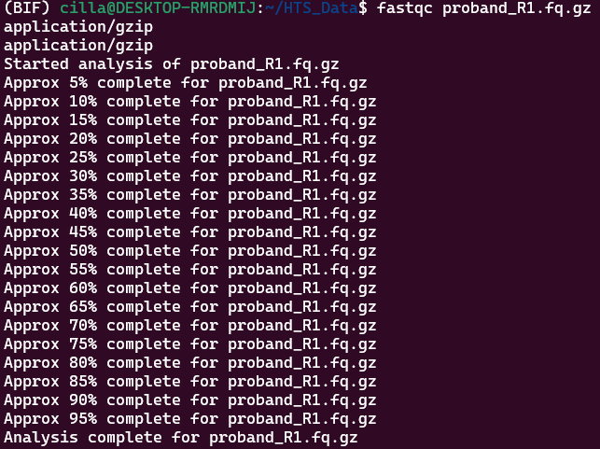

vi. fastqc proband_R2.fq.gz

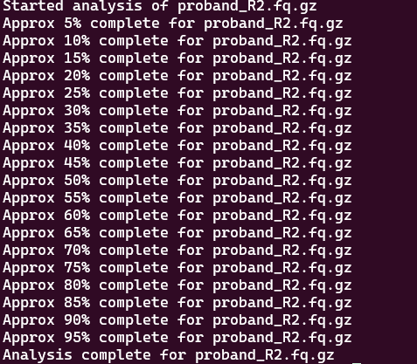

STEP 4: INDEXING THE REFERENCE GENOME

Code used:

STEP 5: READ MAPPING

Code used:

bwa mem -t 8 index/hg19_chr8.fa.gz father_R1.fq.gz father_R2.fq.gz > fatheroutput.sam

bwa mem -t 8 index/hg19_chr8.fa.gz mother_R1.fq.gz mother_R2.fq.gz > motheroutput.sam

bwa mem -t 8 index/hg19_chr8.fa.gz proband_R1.fq.gz proband_R2.fq.gz > probandoutput.sam

STEP 6: CONVERTING SAM FILES TO BAM FILES

Code Used

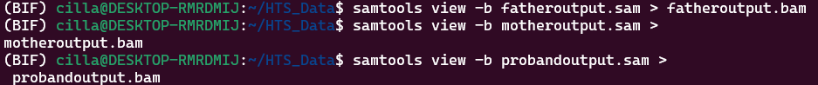

STEP 7: SORTING THE BAM FILES

Code used:

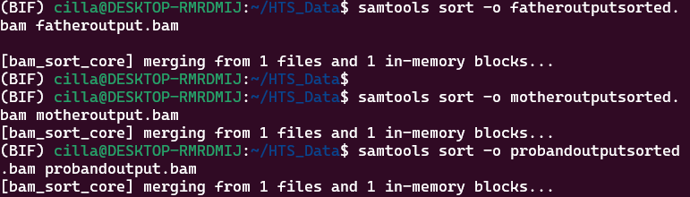

STEP 8: INDEXING THE BAM FILES

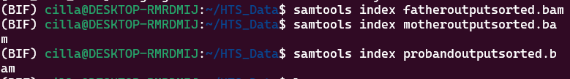

STEP 9: FILTERING THE BAM FILES



STEP 10: REMOVING DUPLICATE READS

First, we sorted the bam files based on names

Code used:

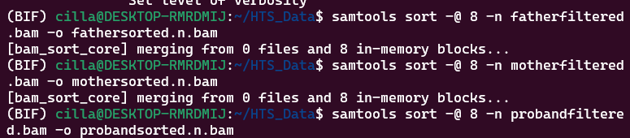

Then we fixmated the sorted files using these codes

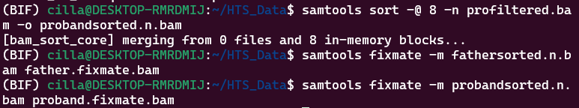

Sorting the fixmated bam files according to coordinates

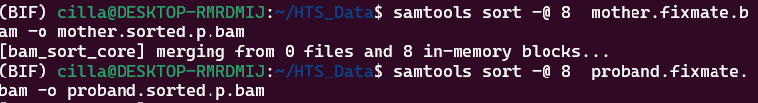

Removing duplicates



STEP 11

VARIANT CALLING

Before performing variant calling, we have to index our dedup bam file

Code Used

